
Project Title: | Multi-Panel Electronics Monitoring System with Web Based Dashboard
Student: | Chan Zi Min Edwin (UP2517673)
Course: | UOP BSc Computer Science
Project code: | PJE40 for Engineering project
Supervisor: | Dr Loo Poh Kok
Date: | May 2026

Declarations (Please tick)

I give permission for this document to be made available to other students as examples of previous work. (optional).
I confirm that I have read and understood the University Rules in respect of plagiarism and student misconduct.
I declare that this work is entirely my own. Each quotation or contribution cited from other work is fully referenced.

Date: ________________

[left intentionally blank]

Acknowledgements – on a new page
on a new page and centred
50 to 100 words
should not appear in contents list
can be coloured if you wish

Abstract – on a new page
on a new page and centred
about 100 words
should not appear in contents list
can be coloured if you wish

Table of Contents – on a new page

Table of Figures – on a new page

Table of Tables – on a new page

Introduction

Electronics Enclosure Monitoring System
Electronics enclosures house crucial components in server rooms, industrial sites, and remote installations. These enclosures contain sensitive equipment susceptible to damage from environmental factors, most notably excessive heat. Prolonged exposure to high temperatures reduces the operational lifespan of electronic components, leads to unpredictable failure, and results in costly unplanned maintenance (Lv, Chu and Wang, 2022). Traditionally, monitoring has relied on manual inspection — a reactive approach where faults are only discovered after damage has occurred.
The rise of Internet of Things (IoT) technology has created an opportunity to replace manual checks with continuous automated monitoring. Low-cost microcontrollers such as the ESP32 can read environmental sensors and transmit data over lightweight communication model protocols like MQTT to a central server for processing and visualization.
This project aimed at developing a multi-panel electronics enclosure monitoring system with automated cooling, critical condition alerts, and a web-based dashboard for real-time status and historical trend analysis. The system was designed to demonstrate how open-source, low-cost technologies could deliver a practical monitoring solution for small-to-medium-scale deployments.

Project Aim and Objectives

The aim of this project was to develop a multi-panel electronics enclosure monitoring system with automated cooling, alert notifications, and a web-based dashboard for real-time monitoring and historical trend analysis.

Objectives:

Research existing IoT monitoring solutions and evaluate suitable communication protocols, backend frameworks, databases, and frontend technologies.

Design a system architecture using MQTT as the communication protocol between sensor nodes and a central backend server.

Develop ESP32 firmware to read temperature and humidity sensors, control cooling automatically, and publish data via MQTT.

Configure a self-hosted Mosquitto MQTT broker with password authentication for secure message routing.

Implement a FastAPI backend server to subscribe to MQTT messages, process sensor data, and store readings in a PostgreSQL database.

Design and populate a PostgreSQL database to maintain current panel state and historical sensor logs.

Build a React-based web dashboard with Chart.js for real-time panel monitoring, historical trend visualisation, and remote system control.

Implement an alert system to detect and log critical conditions (example: high temperature, door timeout, and security breach).

Conduct end-to-end testing across the full system pipeline and evaluate against defined requirements.

Project constraints

The project was subject to the following constraints:

Time - The submission deadline of 23 June 2026 was fixed, limiting the scope of features that could be implemented.

Budget - Self-funded with consumer-grade components. Only one physical ESP32 node was built; the remaining nine panels were simulated.

Hardware - The ESP32 microcontroller only supports 2.4 GHz Wi-Fi, restricting deployment to compatible wireless environments.

Network - All development and testing were conducted on a local home network using a mobile hotspot bridge. No cloud infrastructure was used.

Development environment - All work was performed on personal equipment with no access to dedicated server hardware or university lab resources.

Scope - Features such as RFID access control, message alert notifications, and log for predictive maintenance were deferred to future work to prioritise core monitoring functionality.

Log of risks
# | Risk | Likelihood | Impact | Mitigation | Outcome
1 | Hardware component failure | Low | High | Spare components ordered; 9 of 10 panels simulated to reduce hardware dependency. | Did not occur
2 | Data loss | Medium | High | Version control via GitHub; PostgreSQL database persistence enabled. | Did not occur
3 | Scope creep | Medium | Medium | Core features prioritised; non-essential features deferred to future work. | Mitigated successfully
4 | Component integration complexity | Medium | Medium | Phased development approach; each component tested independently before integration. | Mitigated successfully
5 | Network connectivity failure | Medium | Medium | Network topology documented; mobile hotspot configured as bridge. | Occurred - resolved
6 | RFID module compatibility | Low | Medium | Early testing planned; compatible modules researched. | Not applicable - feature deferred
7 | Personal illness or commitments | Low | High | Buffer time allocated in project schedule. | Occurred - resolved
8 | Network failure during demonstration | Medium | Medium | Mobile hotspot backup prepared; video demonstration recorded as fallback. | Pending confirmation

Project deliverables
The following deliverables were produced upon completion of the project:
Artefacts:
- ESP32 firmware - sensor monitoring, automated fan control, keypad access control, alarm system (buzzer) and MQTT communication.
- Mosquitto MQTT broker - configured with password authentication and message persistence.
- FastAPI backend server - MQTT subscriber, PostgreSQL database integration, and REST API endpoints
- PostgreSQL database - three-table schema for current state tracking and historical event logging.
- React web dashboard - Chart.js visualisation, real-time status monitoring, CSV data Log export, and remote system reset.
Documentation:
- Final project report.
- System architecture diagrams.
- User guide and deployment instructions.
- Source code repository hosted on GitHub (refer to Appendix F).
- Video demonstration of the complete system (refer to Appendix G).

Project Approach

Project Management

The project followed a phased development approach. Early prototyping began with the ESP32 and Adafruit IO as a cloud-based MQTT platform to test sensor communication. However, limitations of the Adafruit platform - such as restricted message rates, limited control over data storage, and dependency on a third-party service - which prompt a shift toward a fully self-hosted stack. This experience directly informed the selection of Mosquitto, FastAPI, and PostgreSQL as replacements, providing full control over the system architecture.

Following the pivot, development was divided into sequential steps, each with clear completion criteria tested before progressing:
Step | Focus | Purpose
1 | ESP32 firmware | Hardware prototype, sensor integration, fan control, keypad access, alarm system, and MQTT publishing.
2 | Mosquitto broker | Self-hosted MQTT broker with password authentication
3 | Development environment | Python virtual environment and package installation
4 | MQTT subscriber | Standalone proof-of-concept to verify broker communication
5 | PostgreSQL database | Schema design, table creation.
6 | FastAPI backend | MQTT ingestion, database writes, and REST API endpoints
7 | React frontend | Web dashboard with visualisation, export, and remote control

Progress was managed using a Gantt chart to track tasks, milestones, and deadlines (see Appendix A). Supervisor meetings were held regularly with Dr. Loo Poh Kok for progress reviews and guidance. Version control was managed through GitHub.

Research
Research combined secondary and primary methods. Secondary research involved reviewing official documentation, online resources, and open-source repositories to evaluate suitable technologies. Primary research involved hands-on prototyping - initial development with Adafruit IO revealed limitations, leading to a pivot to a self-hosted Mosquitto architecture. Both platforms had been introduced during the IoT module. Findings are presented in Section 2.

Legal, ethical, professional, social issues

Legal: All software tools and libraries used in the project were open-source or freely available, including Arduino IDE, Mosquitto, FastAPI, PostgreSQL, and React. No proprietary or licensed software was used. The system collected environmental sensor data only - no personal or identifiable data was stored; therefore, data protection regulations did not apply in the current scope. However, if the system were deployed in a workplace environment with user access logging, data protection compliance would need to be considered.

Ethical:

The project did not involve human participants, personal data collection, or animal testing. All data was generated by environmental sensors and simulated panels. An ethics certificate was obtained and is included in Appendix B.

Professional:

Development followed established software engineering practices including version control (GitHub), modular architecture, structured testing, and technical documentation. Industry-standard technologies were selected to align with professional development standards.

Social:

The system was designed to reduce the need for manual on-site inspection of electronics enclosures, improving workplace safety and operational efficiency. Automated alerts for critical conditions such as overheating and security breaches enable faster response times, reducing the risk of equipment damage and potential safety hazards.

The report

The remainder of this report is structured as follows:

Section 2 presents a literature review of existing IoT monitoring solutions and evaluates the communication protocols, backend frameworks, database systems, and frontend technologies considered for this project.

Section 3 captures the functional and non-functional requirements of the system, including use cases and scope boundaries.

Section 4 describes the system design, covering the overall architecture, database schema, MQTT topic structure, API design, frontend layout, and ESP32 firmware logic.

Section 5 details the development process, walking through each implementation step from ESP32 firmware to the React web dashboard.

Section 6 presents the testing strategy, test plan, results, and evidence demonstrating that the system meets the defined requirements.

Section 7 concludes the report with an evaluation of whether the aim and objectives were met, a review of risks and project management, recommendations for future work, and a final reflection on the project.

2: Literature Review

Introduction

This section reviews the technologies and solutions relevant to the development of the project. It covers IoT monitoring systems, communication protocols, MQTT brokers, backend frameworks, database systems, and frontend technologies. Each section evaluates the available options and the justification for the technology selected.

Research Strategy

Research was conducted using a combination of official documentation, online resources, open-source repositories, and hands-on prototyping. Sources included official documentation for each technology (Mosquitto, FastAPI, PostgreSQL, React, ESP32), developer community resources, and GitHub repositories. Technologies were evaluated based on suitability for IoT applications, ease of integration, community support, and relevance to industry practice. Initial hands-on experience with Adafruit IO during the IoT module also informed the evaluation while testing on the prototype, as its limitations provided first-hand evidence for the selection of a self-hosted architecture.

IoT Monitoring Systems

In industrial and commercial environments, monitoring of equipment such as server rooms, telecommunications enclosures, and electrical panels has traditionally relied on manual inspection or proprietary monitoring solutions. These approaches are often costly, difficult to customize, and impractical for small-to-medium-scale deployments.

The emergence of IoT technology has introduced a more accessible alternative. IoT-based monitoring systems use low-cost microcontrollers and wireless connectivity to collect and transmit sensor data to a central server for processing and visualization. The ESP32, developed by Espressif Systems, is a low-cost, low-power system-on-chip with integrated Wi-Fi and Bluetooth capabilities, making it well-suited for IoT sensor applications (Espressif Systems, 2024).

IoT systems typically follow a layered architecture consisting of a perception layer for data collection, a network layer for data transmission, and an application layer for delivering services to end users (Banaamah and Ahmad, 2024). This project adopted a similar architecture: the ESP32 served as the perception layer, MQTT over Wi-Fi as the network layer, and the FastAPI backend with React dashboard as the application layer.

During the prototyping phase, Adafruit IO - a cloud-based IoT platform - was initially tested. While it provided a simple interface for publishing and visualizing sensor data, it imposed limitations including restricted message rates, limited data retention, and dependency on an external service. These constraints led to the decision to implement a fully self-hosted architecture using Mosquitto, FastAPI, and PostgreSQL, giving complete control over data storage, message handling, and system configuration.

Communication Protocols for IoT

A key design decision for the project was selecting the communication protocol between the ESP32 sensor nodes and the backend server. Three protocols were evaluated:

MQTT is an OASIS standard messaging protocol designed for IoT. It uses a lightweight publish/subscribe model where clients publish messages to topics, and a central broker routes them to subscribers (OASIS, 2014). MQTT was designed for devices with small code footprints and minimal network bandwidth (mqtt.org, no date).

HTTP/REST follows a request/response model where the client must actively poll the server, or the server must be configured to accept incoming data. Each request carries headers that add overhead compared to MQTT's minimal packet structure. For continuous sensor data published at regular intervals, the polling approach introduces unnecessary latency and bandwidth consumption.

WebSockets provide a persistent, full-duplex connection between client and server, enabling real-time bidirectional communication. While effective for browser-to-server applications, maintaining persistent connections on constrained microcontrollers increases power consumption and firmware complexity compared to MQTT's lightweight model.

The publish/subscribe model is illustrated in Figure 2.1.

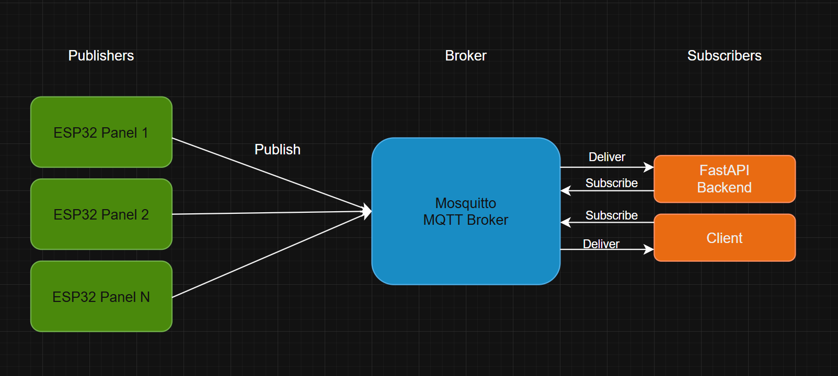

Figure 2.1. MQTT publish/subscribe model.

The following table summarises the comparison:
Feature | MQTT | HTTP/REST | WebSocket
Model | Publish/subscribe | Request/response | Full-duplex
Transport | TCP | TCP | TCP
Overhead | Low (minimal headers) | High (HTTP headers) | Medium
Broker/routing | Yes (central broker) | No | No
Asynchronous | Yes (non-blocking) | No (waits for response) | Yes
Decoupling | Yes (via broker) | No (direct connection) | No (direct connection)
Suitability for constrained devices | High | Low | Medium
One-to-many distribution | Built-in via broker | Requires additional architecture | Requires additional architecture

Justification: MQTT was selected for this project for three key reasons. First, it is asynchronous - the ESP32 publishes sensor data without waiting for a response, allowing the device to continue operating without blocking. Second, it is decoupled - the publish/subscribe model means the ESP32 does not need to know which systems are consuming its data, and the backend can be restarted or replaced without affecting the device. Third, it is lightweight - MQTT's minimal packet headers and small code footprint make it well-suited to the ESP32's constrained resources (OASIS, 2014). These three qualities made MQTT the most suitable protocol for a multi-panel monitoring system where multiple sensor nodes broadcast data to a central backend.

MQTT Broker Comparison

Three MQTT broker platforms were evaluated during the research and prototyping phase:

Adafruit IO is a cloud-based IoT platform that provides MQTT messaging, data storage, and a built-in dashboard. It was tested during early prototyping with the ESP32. However, Adafruit IO's feed structure did not support hierarchical topic organisation - feeds operated at root level rather than being grouped by panel (e.g., panel1/temperature). Additionally, the free tier was limited to 10 feeds, which was insufficient for a multi-panel system requiring five data types per panel across 10 panels. These limitations, combined with dependency on an external service, made Adafruit IO unsuitable for the project.

HiveMQ is a commercial MQTT broker designed for enterprise-scale deployments. It offers advanced features such as clustering, extensive monitoring, and a managed cloud option. However, the full feature set requires a paid licence, and the complexity of the platform exceeded the requirements of this project.

Eclipse Mosquitto is an open-source MQTT broker maintained by the Eclipse Foundation. It is lightweight, supports MQTT versions 5.0, 3.1.1, and 3.1, and is suitable for use on devices ranging from low-power single-board computers to full servers (Eclipse Foundation, no date). Mosquitto supports password-based authentication, message persistence, and configurable logging.

Mosquitto was selected for this project because it provided full control over the broker configuration as a self-hosted solution, it is open-source and free to use, it is lightweight enough to run alongside the backend on a single development machine, and it is widely documented with strong community support.

Backend Framework Selection

The backend framework was selected based on industry relevance and suitability for the project requirements. FastAPI is a modern Python web framework designed for building APIs. It provides automatic interactive API documentation via Swagger UI, enabling developers to test REST API endpoints directly from the browser without additional tools (FastAPI, no date). FastAPI was chosen for this project because it is widely adopted in industry, it integrates well with Python-based MQTT libraries such as paho-mqtt, and the built-in Swagger UI significantly simplified API testing during development.

Database Selection

The database was selected based on industry relevance and suitability for structured sensor data storage. PostgreSQL is an open-source relational database system known for its reliability, data integrity, and support for complex queries (PostgreSQL, no date). It enforces referential integrity through foreign keys, ensuring consistency between related tables. PostgreSQL was chosen for this project because it is widely adopted in industry, it supports the relational structure needed for linking panels to their sensor readings and alerts, and it is well-supported by Python through the psycopg2 library.

Frontend Framework Selection

The frontend framework was selected based on industry relevance, suitability for building an interactive dashboard, and prior experience. React is an open-source JavaScript library developed by Meta for building component-based user interfaces (React, no date). The developer had prior experience with React from the Software Engineering Theory and Practice module, which reduced the learning curve. React was chosen for this project because it is widely adopted in industry, its component architecture supports separation of concerns between different parts of the dashboard, and it integrates well with Chart.js for data visualisation through the react-chartjs-2 wrapper library.

Summary

This section reviewed the technologies relevant to the project and provided justification for each selection. IoT monitoring systems were examined to understand common architectures and identify the opportunity for a low-cost, self-hosted solution. MQTT was selected as the communication protocol for its asynchronous, decoupled, and lightweight characteristics. Mosquitto was chosen as the MQTT broker after first-hand testing of Adafruit IO revealed structural and scalability limitations. FastAPI, PostgreSQL, and React were each selected based on industry relevance, project suitability, and in the case of React, prior experience. Thus, these technologies formed a fully open-source, self-hosted stack providing complete control over the system architecture.

3: Requirements Capture (Analysis)

Introduction

This section defines the functional and non-functional requirements of the monitoring system. Requirements were derived from the project brief, supervisor guidance, domain research, and first-hand experience during prototyping. Each requirement is assigned a priority and is later mapped to test cases in Section 6.

Functional Requirements

The following functional requirements were identified for the system:
ID | Requirement | Priority
FR1 | The system shall read temperature and humidity from sensors at 10-second intervals | Must
FR2 | The system shall publish sensor data to an MQTT broker | Must
FR3 | The system shall activate fan cooling when temperature reaches 45°C and deactivates at 38°C (hysteresis) | Must
FR4 | The system shall trigger a critical alarm when temperature exceeds 75°C | Must
FR5 | The system shall detect door open/close events via reed switch | Must
FR6 | The system shall trigger a timeout alarm if the door remains open for 60 seconds without password entry | Must
FR7 | The system shall trigger a security alarm after three incorrect password attempts | Must
FR8 | The system shall store current panel state and historical sensor readings in a database | Must
FR9 | The system shall display all panel statuses on a web dashboard | Must
FR10 | The system shall display historical temperature and humidity charts | Should
FR11 | The system shall allow remote system reset via the dashboard | Should
FR12 | The system shall provide CSV export of sensor readings and alerts | Should
FR13 | The system shall indicate online/offline status per panel | Should
FR14 | The system shall display colour-coded status indicators for critical conditions | Should
FR15 | The system shall support monitoring of up to 10 panels (1 physical, 9 simulated) | Must

Non-Functional Requirements

The following non-functional requirements define the quality attributes of the system:
ID | Requirement | Category
NFR1 | The dashboard shall update panel data within 5 seconds of new sensor readings | Performance
NFR2 | The system shall support monitoring of 10 panels simultaneously | Scalability
NFR3 | The backend shall remain operational and serve last-known data if the MQTT connection drops | Reliability
NFR4 | MQTT communication shall use password-based authentication | Security
NFR5 | The dashboard shall display a warning banner when the backend is unreachable | Usability
NFR6 | The dashboard shall use colour-coded indicators matching firmware thresholds (green, amber, red) | Usability
NFR7 | The system shall operate on a local network without cloud dependency | Deployment
NFR8 | The frontend shall provide a basic responsive layout for smaller screens | Usability

Use Cases

The following use cases describe the key interactions between the operator and the system:
UC | Actor | Description
UC1 | Operator | View a list of all panels in the sidebar with online/offline status indicators
UC2 | Operator | Select a panel from the sidebar to view detailed status including temperature, humidity, door, fan, and alarm status
UC3 | Operator | View historical temperature and humidity trends for the selected panel over the past 30 days
UC4 | System | Detect a critical condition (high temperature, door timeout, or security breach) and create an alert record in the database
UC5 | Operator | Perform a remote system reset on a panel via the dashboard
UC6 | Operator | Export sensor readings or alerts as a CSV file for a selected panel based on past records
UC7 | On-site technician | Enter password on keypad to authenticate that the person opening the door is authorised personnel, preventing a security alarm from triggering
UC8 | On-site technician | Acknowledge a critical temperature alarm by double-pressing the reset button to silence the buzzer while performing on-site maintenance

Scopes of Boundaries

The following table defines what was included within the project scope and what was deliberately excluded:
In Scope | Out of Scope (Future Work)
1 physical ESP32 panel with 9 simulated panels | RFID access control: card scan combined with passcode entry to authenticate individual personnel and log access records
Temperature and humidity monitoring with automated fan control | Message alert notifications (email/SMS): notify operators when critical conditions occur or unauthorised personnel open the door, enabling immediate response without monitoring the dashboard
Door access control with keypad authentication | Predictive maintenance prompts: the system does not prompt operators to schedule maintenance based on recurring patterns
Alert system for critical temperature, door timeout, and security breach | Docker containerisation
Self-hosted Mosquitto MQTT broker with password authentication | Cloud deployment (Linode/AWS)
FastAPI backend with REST API and MQTT subscriber | TLS/SSL encryption for MQTT
PostgreSQL database for current state and historical logging | Alert recovery logging: the current system records when alerts are triggered but does not record when errors are resolved
React web dashboard with Chart.js visualisation | User authentication for the dashboard: without login, any user with the URL could access the system and perform actions such as repeated system resets
CSV export of sensor readings and alerts | Automated testing framework
Remote system reset via dashboard | Mobile-first responsive redesign

The system was developed as a working prototype for demonstration and evaluation purposes. All development and testing were conducted on a local network. Cloud -based deployment and Docker containerisation were considered but placed outside the current scope and are recommended as future enhancements (see Section 7).

Summary

This section defined the functional and non-functional requirements of the monitoring system, identified key use cases for both remote operators and on-site technicians, and established clear scope boundaries. A total of 15 functional requirements and 8 non-functional requirements were identified, all of which were implemented and are evaluated against test cases in Section 6.

4: Design

Introduction

This section describes the design of the monitoring system, covering the overall architecture, data flow, database schema, MQTT topic structure, REST API endpoints, frontend layout, and ESP32 firmware logic. Design decisions reference the technology selections justified in Section 2.

System Architecture
The system follows a layered architecture consisting of five main components connected through two communication protocols. The architecture is illustrated in Figure 4.1.
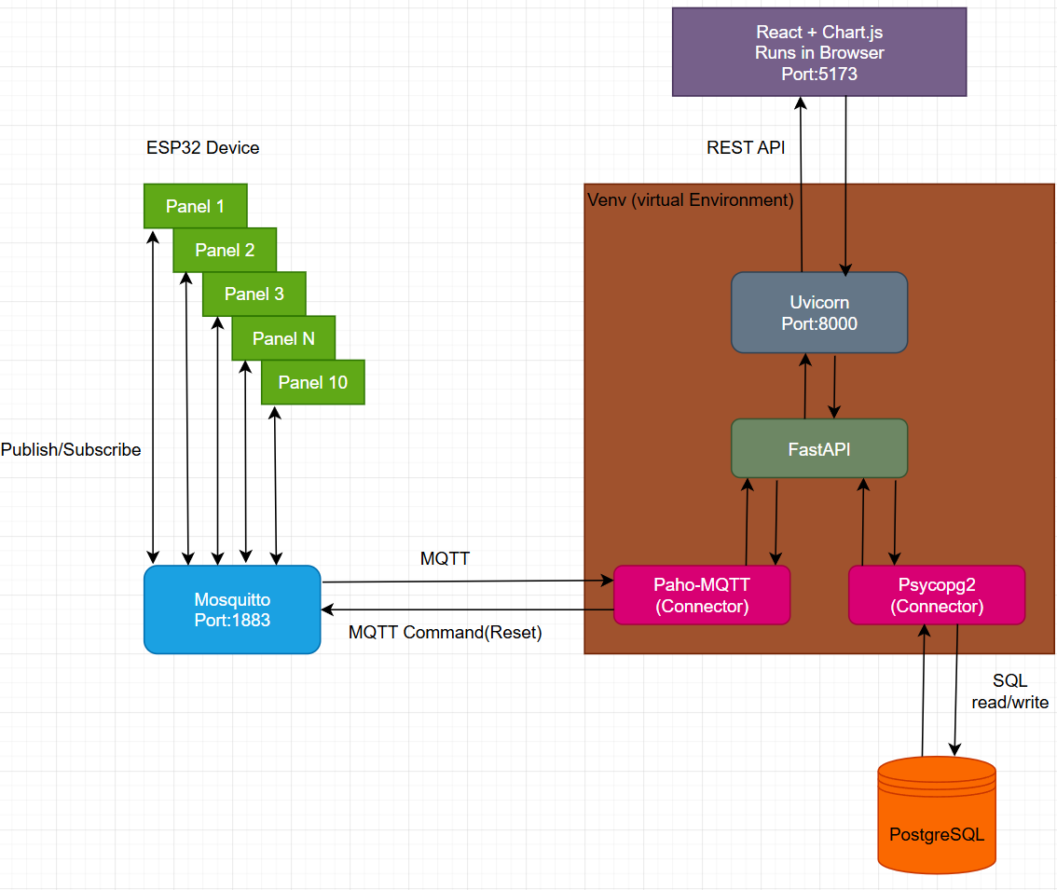
Figure 4.1. System architecture diagram.
At the perception layer, the ESP32 microcontroller reads temperature and humidity data from the DHT11 sensor and monitors door, fan, and alarm status. Sensor data is published to the Mosquitto MQTT broker over Wi-Fi using the PubSubClient library.
The Mosquitto broker acts as the central message router, receiving published messages from the ESP32 and delivering them to subscribed clients. Password-based authentication is enforced for all connections.
The FastAPI backend operates as both an MQTT subscriber and an HTTP server. A background thread subscribes to all panel topics via paho-mqtt and writes incoming data to the PostgreSQL database. The main thread serves REST API endpoints to the frontend via uvicorn on port 8000.
PostgreSQL stores data across three tables: a rolling current-state table for each panel, an append-only sensor readings log, and an append-only alert log. The database acts as a shared data store between the MQTT subscriber and REST API — providing loose coupling between the two subsystems.
The React frontend polls the REST API every 5 seconds and renders the dashboard. React never communicates with PostgreSQL or Mosquitto directly — all data flows through the FastAPI backend.
This architecture provides fault tolerance through loose coupling. If the MQTT connection drops, the REST API continues serving last-known data from PostgreSQL. If the frontend is unavailable, the backend continues receiving and storing sensor data.

Data Flow
The system supports two directional data flows: sensor data flowing inward from the ESP32 to the dashboard, and control commands flowing outward from the dashboard to the ESP32.

Figure 4.2. Data flow diagram.
Sensor Data Flow (inbound):
- The ESP32 reads temperature and humidity from the DHT11 sensor every 10 seconds.
- Each reading is published as a separate MQTT message to the Mosquitto broker (e.g., panel/1/temperature, panel/1/humidity).
- The FastAPI backend receives the message via the paho-mqtt on message callback
- The callback writes to PostgreSQL: an INSERT into sensor readings (append-only log) and an UPDATE to the panels table (current state).
- If the reading triggers an alert condition (temperature ≥ 75°C), an INSERT is made into the alerts table.
- The React dashboard polls GET /panels every 5 seconds and renders the updated data.

Control Command Flow (outbound):

The operator clicks the "Reboot" button on the dashboard

React sends a POST /panels/{id}/control/reset request to FastAPI

FastAPI publishes a "RESET" payload to panel/{id}/control/reset via MQTT

Mosquitto routes the message to the ESP32

The ESP32 executes performFullSystemReset()

The two flows are loosely coupled through PostgreSQL. The inbound flow writes to the database, and the dashboard reads from it. The only point where the two flows connect directly is the reset command, where FastAPI publishes back to the MQTT broker.

Database Design

MQTT Topic Design

API Design

Frontend Design

ESP32 Firmware Design

5: Development – on a new page

Introduction

Etc

Etc

Summary

6: Testing

Introduction

Test plan

Results

Etc

Summary

7: Conclusion– on a new page

Recommendations

Aim & Objectives (were they met)

Risks (did any happen, was your mitigation ok?)

Project Management (did it work? Was your Gantt Chart ok etc)

Etc

Conclusion

References– on a new page

Lv, Y.-G., Chu, W.-X. and Wang, Q.-W. (2022) 'Thermal management systems for electronics using in deep downhole environment: A review', International Communications in Heat and Mass Transfer, 139, 106450. Available at:https://www.sciencedirect.com/science/article/abs/pii/S0735193322005723

Banaamah, A.M. and Ahmad, I. (2024) 'Internet of Things: a comprehensive overview, architectures, applications, simulation tools,challenges and future directions', Discover Internet of Things, 4(1). Available at: https://doi.org/10.1007/s43926-024-00084-3

Espressif Systems (2024) ESP32 Series Datasheet, version 5.2. Available at: https://www.espressif.com/sites/default/files/documentation/esp32_datasheet_en.pdf (Accessed: May 2026).

OASIS (2014) MQTT Version 3.1.1, OASIS Standard. Available at: https://docs.oasis-open.org/mqtt/mqtt/v3.1.1/os/mqtt-v3.1.1-os.html (Accessed: May 2026).

mqtt.org (no date) MQTT - The Standard for IoT Messaging. Available at: https://mqtt.org/ (Accessed: May 2026).

Eclipse Foundation (no date) Eclipse Mosquitto — An Open Source MQTT Broker. Available at: https://mosquitto.org/ (Accessed: May 2026).

FastAPI (no date) FastAPI Documentation. Available at: https://fastapi.tiangolo.com/ (Accessed: May 2026).

PostgreSQL (no date) PostgreSQL: The World's Most Advanced Open Source Relational Database. Available at: https://www.postgresql.org/ (Accessed: May 2026).

React (no date) React Documentation. Available at: https://react.dev/ (Accessed: May 2026).

Appendices – on a new page

Appendix A: Project Initiation Document (inc Gantt Chart)
Copy & paste into this document

Appendix B : Ethics Certificate – on a new page

You might also have as appendices your requirements specification, any UML diagrams etc

